AI Agent — From Prototype to Enterprise Production
Series Overview
- The series focuses on building an AI agent from zero to production.
- It is a 10-video, project-driven series.
- Instead of learning concepts individually, concepts are learned by building a real-time project.
- The main project is a Kubernetes Investigation Agent.

Complete Agent Lifecycle
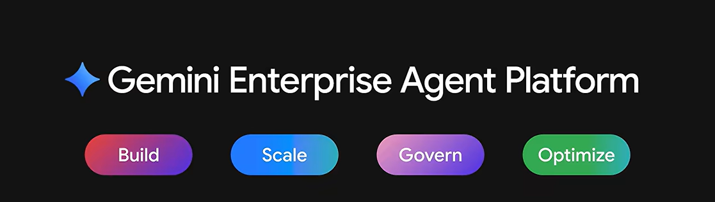
The series covers four major areas:
- Building an AI Agent
- Deploying and Scaling the Agent
- Governing the Agent
- Observing the Agent in Production

Technologies / Platform
- Gemini Enterprise Agent Platform
- Google Cloud Platform
- The project is used to demonstrate how an AI agent moves from a prototype to an enterprise-grade system

Prototype vs Enterprise AI Agent
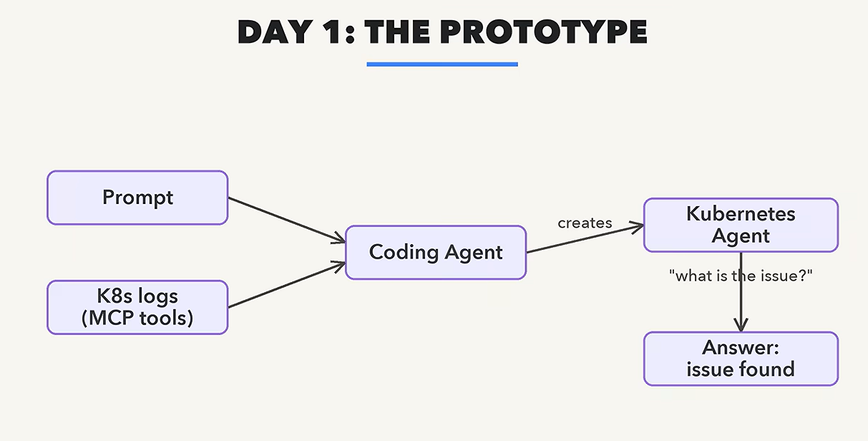
A prototype can demonstrate that an agent works.

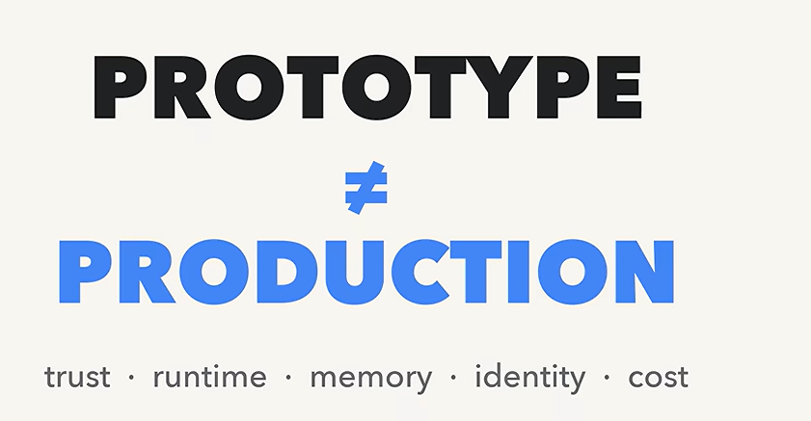
A production agent must demonstrate that the agent is:
- Trustworthy
- Scalable
- Secure
- Observable
- Cost-controlled
- Governed
- Able to maintain relevant memory
- Properly identified and authorized
Why a Prototype Cannot Directly Go to Production
When moving an AI agent to production, several important questions appear:
- Can we trust the agent's answers?
- Where will the agent run?
- Can it remember previous incidents?
- Who is the agent?
- What is the agent allowed to access?
- Can we see what the agent did?
- How much does the agent cost to run?
- Who is accountable for the agent?
These concerns are what separate a simple prototype from an enterprise production system

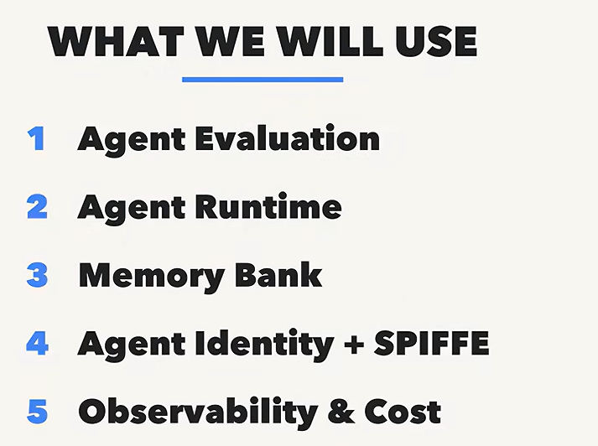

Main Enterprise AI Agent Features:
Production Concern | Feature / Approach
Trust / quality | Agent Evaluation
Deployment & scaling | Agent Runtime
Persistent context | Memory Bank
Identity & permissions | Agent Identity
Workload identity | SPIFFE
Monitoring | Google Cloud Observability
Cost control | Google Cloud Cost Management
Model selection | Model Garden

Interview / Revision Points
Q1. What is the difference between Day 1 and Day 2 operations?
- Day 1: Building and validating the prototype.
- Day 2: Operating the agent as a production/enterprise system.
- Day 2 introduces concerns such as scaling, trust, memory, identity, observability, and cost.
Q2. Why can't a prototype directly go to production?
Because a prototype may not address:
- Trustworthiness
- Scalability
- Runtime management
- Persistent memory
- Identity
- Permissions
- Observability
- Cost management
- Governance
Q3. What is Agent Runtime?
- Provides the production environment for deploying agents.
- Supports running and scaling agents.
Q4. Why is Agent Evaluation required?
- AI responses cannot be blindly trusted.
- Evaluation helps assess the quality of agent responses.
Q5. What is Memory Bank?
- Provides persistent memory.
- Allows an agent to maintain relevant context beyond a single interaction/session.
Q6. Why does an agent need an identity?
Because different agents may need different permissions.
Example:
- Investigation agent → Read access
- Infrastructure modification agent → Read + Write access
Q7. Why is observability important?
To understand:
- What the agent did
- When it did it
- What went wrong
- How successful it was
Q8. Why is cost management important?
Because production AI agents consume:
- Models
- Compute
- Infrastructure
Without monitoring, operational costs can increase significantly.
Q9. What is Model Garden?
- A place to explore and select different models.
- Includes Google and third-party models.
- Can help choose models appropriate for different workloads.

⭐ One-Line Takeaway
A prototype proves that an AI agent can work; an enterprise agent proves that it can be trusted, deployed, scaled, governed, observed, secured, and operated at an acceptable cost.

